Temasek Polytechnic
School of Informatics and IT

Diploma in Information Technology (IT)

Project Plan

Project Particulars

Tutor | Goh Mya Hu, Mel
Class | P01
Project Title | Delonix Regia Hotel Management System

Project Team’s Particulars

Matric Number | Student Name
1506070J | Lexus George
1503103B | Ryan Ng Zi Feng
1501169E | Yip Cherng Yorng
1502712A | Leng Yin Long

Revision History

Date | Version | Description | Author
08/04/2017 | 1.0 | Added work breakdown structure, project schedule and budget summary | Lexus
09/04/2017 | 1.1 | Adjustments to roles and responsibility, risk management plan, workload distribution | Lexus

Table of Contents
1. Introduction 4
1.1 Objectives and scope of the project 4
1.2 Assumptions and constraints 4
1.3 Definitions and acronyms 4
2. Roles and responsibilities 5
3. Estimates and project schedule 6
3.1 Work breakdown structure 6
3.2 Project Schedule 7
3.3 Budget Summary 9
4. Risk Management Plan 10

Project Plan

Introduction

Objectives and scope of the project

The objectives are to create a hotel management system for Delonix Regia, using visual basic products like Visual studio and creating a user manual for staff and guest on how to use the system implemented to the hotel. The key features of the software are the staff members to manage the hotels daily operations and transactions to maximize the hotel revenue and attract more guest to come to stay at the hotel. Some features like allowing guests to be able to book special services such as laundry, ironing and room service.

Assumptions and constraints

Assumptions
- The hotel is using a manual system to handle its process.
- It uses file based management, where the management uses a lot of effort to secure the files
- Booking is done by phone calls.

Constraints
- Unable to commit to requirements stated
- Hard to obtain resources needed for hardware
- Not enough required specialist to complete the project
- Different time schedules to meet up for meetings
- Not enough time to do necessary testing of software
- Last minute changes can be challenging

Definitions and acronyms

TOR - Terms of Reference
SRS - Software Requirement Specification
SDS - Software Design Specification
STS - Software Test Specification

Roles and responsibilities

Roles | Responsibility | Member
System Analyst | - Gathering required information  - Documenting project requirements | Cherng Yorng, Yin Long
Designers | - Analyze software specification  - Convert requirements for programmers to understand | Ryan, Yin Long
Developers | - Code the work using required software | Ryan, Cherng Yorng
DB Administrators | - Create database with the standard steps of database designing  - Adjustments and maintaining the database accordingly to requirements by other developers | Lexus
Tester | - Making sure all stated requirements, goals and objectives of the application is met | Lexus

Workload Distribution | Members
Objectives and scope of project  Assumption and Constraints  Roles and Responsibilities | Lexus George
Work Breakdown Structure  Definitions and acronyms | Ryan Ng Zi Feng
Budget Summary  Risk Management Plan | Yip Cherng Yorng
Project Schedule  Risk Management Plan | Leng Yin Long

Estimates and project schedule

Work breakdown structure

1.1 Hotel Management System
1.1 Initiation
1.1.1 Develop TOR
1.1.2 Develop Project Plan
1.2 Planning
1.2.1 Complete SRS
1.2.2 Complete SDS
1.3 Execution
1.3.1 Develop Hotel Booking Function
1.3.1.1 Develop Room Booking Function
1.3.1.2 Develop Facility Booking Function
1.3.2 Develop Room Service Function
1.3.3 Develop Housekeeping Function
1.3.5 Create System
1.3.6 Complete STS
1.4 Control
1.4.1 Risk Management
1.5 Closure
1.5.1 Audit Procurement
1.5.2 Document Lessons Learned
1.5.3 Update Files/Records
1.5.4 Gain Formal Acceptance
1.5.5 Archive Files/Documents
    - Close Project

Project Schedule

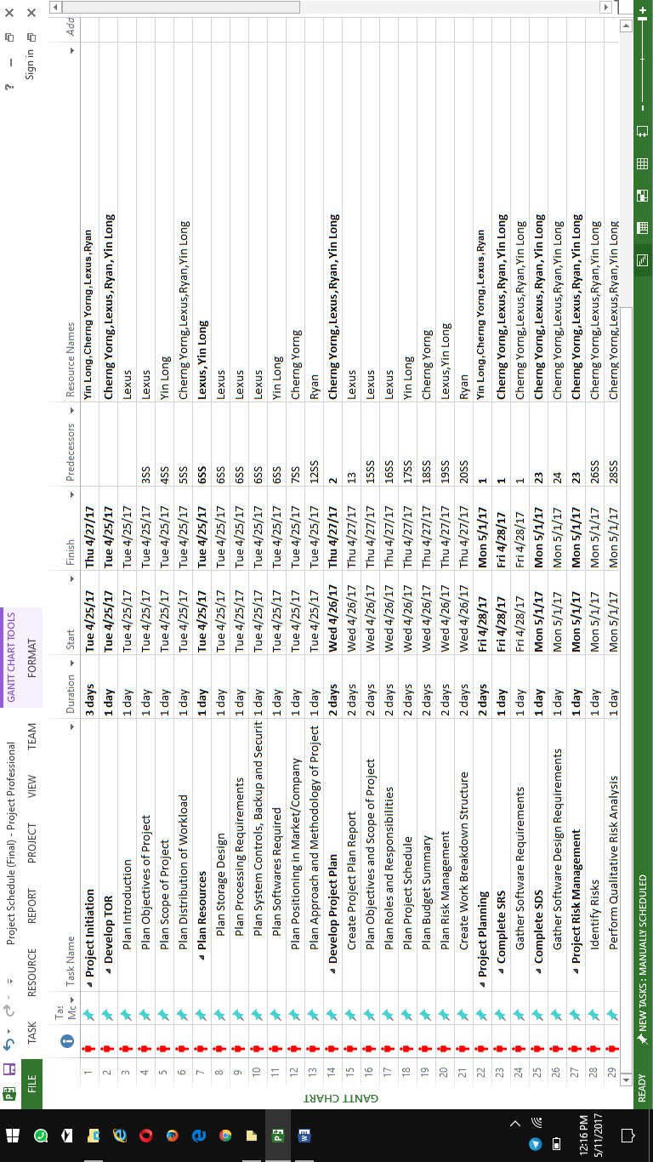

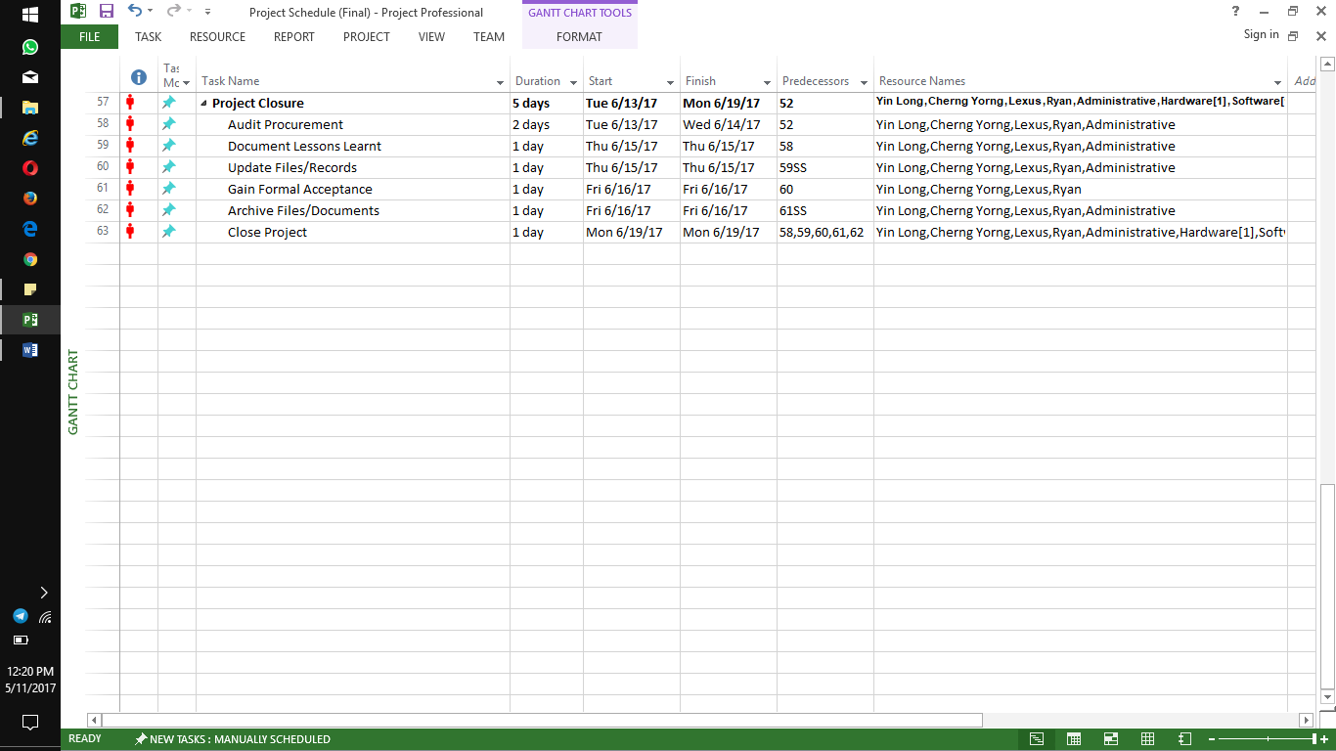
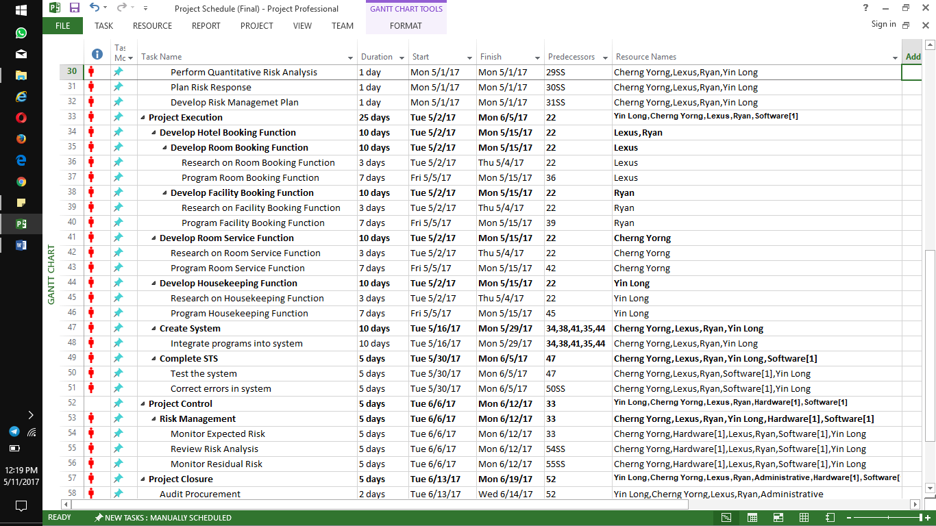
Project Initiation & Project Planning

Project initiation and project planning will be done over the course of 1 week, which consist of 5 working days. TOR, project plan, work breakdown structure, SRS and SDS will be completed by the end of the week and they will be done by everyone in the group.

Project Execution

Project execution will be done over the course of 5 weeks, which consist of 25 working days. Development of hotel booking function, room service function and housekeeping function will be completed within the following 10 days after the project initiation and project planning is completed. Once the functions are in place, we will begin to program and create the system over the next 10 days, and the last 5 days will be to complete the STS.

Risk Control

Risk control will be done over the course of 1 week, which consist of 5 working days. Risk control will ensure that the system runs smoothly as intended. Should issues and problems arise, this is when we find solutions or methods to minimize the problem.

Project Closure

Project closure will be done over the course of 1 week, which consist of 5 working days. Audit procurement will be done over 2 days after risk control is completed. Once completed, files and records are to be documented and updated to match the current project status over the next day. This will ensure that the future updates to the system and the handover will be smoother and easier for the both the users and the future project managers. Once that is done, the last day of the project will be to gain formal acceptance and archive all the files and documents for future use.

Budget Summary
Item | Amount ($)
Manpower | $81,000
  Security and analytics management (4)  $35 x 9hr | $31,500
  Software Engineers (5)  $30 x 9hr | $33,750
  Cyber Security Engineers (2)  $25 x 9hr x 10days | $4,500
  Trainer (2)  $25x 9hr | $11,250
Hardware | $4,719.99
  Computer (4) | $1,719.99
  Server (1) | $3,000
Software | $2,565
  Antivirus | $1,190
  Server-based Firewall | $1,375
TOTAL | $88,284.99

Risk Management Plan

Structure/Process Risk
Possible Risk(s)
- If process is not followed strictly, the integrity of the data collected will be at risk.
- If the time needed for a process is more than the estimated schedule, the schedule for other process will be delay.

Risk Reduction/Prevention Strategies
- Discuss with the development team to confirm with them if the estimated schedule is enough for them to finish developing their parts.

People Risk
Possible Risk(s)
- Employee may quit during the middle of the project.
- Conflicts may arise if clients keep changing their mind in the project specifications.

Risk Reduction/Prevention Strategies
- Have the employee to sign a contract so that when they want to leave halfway, they will need to pay a sum of money. Also, have the project manager to know some developer as backup.
- Make sure that every decision made is less confirmed and less prone to changes. (Critical Thinking)

Financial Risk
Possible Risk(s)
- Running out of budget due to addition processes added.

Risk Reduction/Prevention Strategies
- Have a meeting to estimate the budget for the project before starting to develop it. Also, we can have miscellaneous budget as backup.
- Ensure that the processes and functions are finalized before starting off the project.

Technology Risk
Possible Risk(s)
- When the team have to reduce some of the function of the system as there's a conflict in implementing the whole function into the software and the performance of it.
- System used may be outdated if not updated frequently to the most current security and data integrity standards

Risk Reduction/Prevention Strategies
- Have a meeting with the development team to discuss if implementation of the system is possible while maintaining the performance of it.
- Have monthly system maintenance to ensure that everything in the system is up-to-date

Market Risk
Possible Risk(s)
- If there are changes in the price of equipment, the budget estimation will be off.

Risk Reduction/Prevention Strategies
- Have some backup of other equipment budget estimation so that if the price of the equipment has change, we can buy the other equipment.

